**COS30019 – Mid-Semester Test**

**Answering Instructions:**

Please do not use a red pen/type in red.

There are 4 problems.

Total marks on paper: 70 marks + 4 bonus marks

The maximum mark you can get for the Mid-Semester Test is 70 (100%). However, if you lose marks in some questions and you get the bonus marks, the bonus marks will be added to your total of the Mid-Semester Test.

**Student Name: Hai Nam Ngo**

**Student ID: 103488515**

**Problem 1 – State True or False (5x2 = 10 marks)**

1. A simple-reflex agent will maximise the expected performance measure in a partially observable environment.

Answer: False

1. In a deterministic environment, if you are in state S0 and you perform action A, the probability of reaching the next state S1 is 1.

Answer: True

1. Breadth-first search (BFS) with repeated state check can guarantee to find the optimal solution.

Answer: True

1. Greedy Best First Search (GBFS) with an admissible heuristic function can guarantee to find the optimal solution.

Answer: False

1. Alpha-beta pruning with a heuristic evaluation function yields an optimal playing strategy against an optimal opponent.

Answer: False

**Problem 2 – Multiple-choice questions (12 marks)**

**(You can choose more than one option.)**

1. Consider the maze below for the robot navigation problem, where being at either G1 or G2 satisfies the goal test. Shaded cells represent the wall. The robot can only travel north, south, east or west.

|  |  |  |  |  |  |  |
| --- | --- | --- | --- | --- | --- | --- |
|  | 1 | 2 | 3 | 4 | 5 | 6 |
| 1 |  |  |  |  |  |  |
| 2 |  |  |  |  |  | G2 |
| 3 |  |  |  |  |  |  |
| 4 | G1 |  |  |  |  |  |

Assume that MD(*S1*, *S2*) is the Manhattan Distance between two squares *S1* and *S2*, and max[*x*, *y*] returns the biggest value of *x* and *y*, and min[*x*, *y*] returns the smallest value of *x* and *y*. Which of the following heuristic function for a square *S* is admissible?

1. h(*S*) = MD(*S*, G1)
2. h(*S*) = min[MD(*S*, G1), MD(*S*, G2)]
3. h(*S*) = max[MD(*S*, G1), MD(*S*, G2)]
4. h(*S*) = MD(*S*, G1) + MD(*S*, G2)

**Answer: B**

Option B chooses the shorter of the two distances to G1 or G2, resulting in an underestimate or exact cost to the closest goal, making it admissible.

(4 marks)

2. Consider the Vacuum Cleaner World discussed in the lecture. If the agent does not know the geography of the environment and a room may become dirty again after being cleaned then what type of agent would best be used?

1. Simple reflex agent
2. Utility-based agent with learning
3. Goal-based agent
4. Rule-based agent with internal states.

**Answer: B**

(4 marks)

3. Which of the following statements can be used to define various paradigms of Artificial Intelligence (AI)?

1. AI as a system that acts rationally aims to pass the Turing test.
2. AI as a system that thinks rationally aims to maximise the value of the performance measure.
3. AI as a system that thinks like a human always follows logical reasoning.
4. AI as a system that acts like a human aims to create machines that perform functions that require intelligence when performed by people.

**Answer: B, D**

(4 marks)

**Problem 3 – Search (30 marks**+ 4 bonus marks**)**

Consider the search space below, where **A** is the initial state and **both states GandHsatisfy the goal test**. Arcs are labelled with the cost of traversing them; for instance, traversing from **A** to **B** costs 5. And the estimated (heuristic) cost to the nearest goal is reported inside nodes. That is, the following heuristic function *h*() is used: *h*(**A**) = 7;  *h*(**B**) = 8; *h*(**C**) = 5; *h*(**D**) = 7;  *h*(**E**) = 10; *h*(**F**) = 3; *h*(**G**) = *h*(**H**) = 0.

(6x5 = 30 marks) + 4 bonus marks

1

2

12

5

3

5

4

5

7

7

18

5

For each of the following **tree-based search strategies**, you are given a list of options. Each option describes, using that search strategy, the solution found (if any) and the sequence of all the states associated with the expanded nodes on the search tree. **When all else is equal**, the agent should try to expand the successor state of a state according to the **alphabetical order**.

***Please select one option that correctly describes the search strategy.***

***Hints:*** ***(i)*** *The sequence of expanded nodes is NOT the same as the solution. It is the nodes on your search tree that are expanded, in order, according to the search strategy.*

***(ii)*** *You may not always traverse directly from one node to another. For instance, you can directly traverse from* **A** *to* **B***, but you cannot directly traverse from* **A** *to* **C***.*

***(iii)*** *If you want to insert extra information to explain your answer (such as the search tree you draw), please feel free to do so.*

1. Which of the following options correctly describes Breadth First Search (BFS) **with** repeated state check?

(d)

1. Solution found: **A-B-F-G**; expanded nodes: **A, B, C, D, E, F, G**
2. Solution found: **A-E-G**; expanded nodes: **A, B, D, E, F, C, D, G**
3. Solution found: **A-E-G**; expanded nodes: **A, B, D, E, A, F, C, D, G**
4. Solution found: **A-B-F-G**; expanded nodes: **A, B, D, E, F, G**
5. Solution found: **A-B-F-G**; expanded nodes: **A, B, F, G**

I will answer this question by using logical explanation:

The starting node will be always A in this case, and next it will expand to three other child nodes, which is B, D, E. So, the only three possible correct answer will be solution (b), (c) and (d).

However:

In solution (b), there is duplicate node in the expanded nodes list, which is D.

In solution (c), there is duplicate node in the expanded nodes list, which is A.

This is not accepted because we have repeated state check.

So, the only answer for this question is solution (d).

(5 marks)

(e)

2. Which of the following options correctly describes Depth First Search (DFS) **without** repeated state check?

1. Solution found: **A-B-F-G**; expanded nodes: **A, B, F, G**
2. Solution found: **A-C-G**; expanded nodes: **A, C, G**
3. Solution found: **A-D-C-G**; expanded nodes: **A, D, C, G**
4. Solution found: **A-E-G**; expanded nodes: **A, E, G**
5. Solution found: **No**; expanded nodes: **A, B, A, B, …. Infinite loop**

Explanation: Without repeated state check, when exploring node B, it will then comeback to node A (because of the affect of LIFO queue, which will create an infinite loop, and never can reach the goal node.

(5 marks)

(b)

3. Which of the following options correctly describes Depth First Search (DFS) **with** repeated state check?

1. Solution found: **A-B-F-G**; expanded nodes: **A, B, F, G**
2. Solution found: **A-D-C-H**; expanded nodes: **A, D, C, H**
3. Solution found: **A-D-C-G**; expanded nodes: **A, D, C, G**
4. Solution found: **A-E-G**; expanded nodes: **A, E, G**
5. Solution found: **No**; expanded nodes: **A, B, A, B, …. Infinite loop**

Explanation:

Because this is DFS, so according to the graph tree, it will explore the first branch (B branch), before exploring any other branch.

(5 marks)

(b)

4. Which of the following options correctly describes Greedy Best First Search (GBFS) **with** repeated state check?

1. Solution found: **A-E-G**; expanded nodes: **A, B, D, E, G**
2. Solution found: **A-D-C-G**; expanded nodes: **A, D, C, G**
3. Solution found: **A-D-C-H**; expanded nodes: **A, D, C, H**
4. Solution found: **A-E-D-C-H**; expanded nodes: **A, E, D, C, H**
5. Solution found: **A-E-D-C-G**; expanded nodes: **A, B, B, E, C,**

(5 marks)

(d)

5. Which of the following options correctly describes A* **without** repeated state check?

1. Solution found: **A-E-D-C-H**; expanded nodes: **A, E, D, C, H**
2. Solution found: **A-E-D-C-H**; expanded nodes: **A, E, B, D, F, C, H**
3. Solution found: **A-E-D-C-H**; expanded nodes: **A, E, B, A, D, F, C, H**
4. Solution found: **A-B-F-G**; expanded nodes: **A, B, F, G**
5. Solution found: **A-D-C-G**; expanded nodes: **A, D, C, G**

(5 marks + 2 bonus marks)

(c)

6. Which of the following options correctly describes A* **with** repeated state check?

1. Solution found: **A-E-D-C-H**; expanded nodes: **A, E, D, C, H**
2. Solution found: **A-E-D-C-H**; expanded nodes: **A, E, B, D, F, C, H**
3. Solution found: **A-B-F-G**; expanded nodes: **A, B, F, G**
4. Solution found: **A-D-C-G**; expanded nodes: **A, D, C, G**
5. Solution found: **A-D-C-H**; expanded nodes: **A, D, C, H**

(5 marks + 2 bonus marks)

**Problem 4 – Game Playing and Expected Values (18 marks)**

Consider the following game tree in which the utility values are shown below each leaf node.

**4**

**2**

**9**

**10**

**5**

**8**

**1**

**3**

**15**

**12**

**6**

**3**

**2**

00

Assume that the root node corresponds to the maximising player. That is, **the first player (MAX)** is trying to maximise the final score. Assume that **the search always visits children left-to-right**.

***Hints:*** *If you want to insert extra information to explain your answer (such as game tree with details of alpha and beta), please feel free to do so.*

For each of the following questions, choose one option:

1

1. According to **minimax**, the best first move for player MAX at node **A** is:
   1. MAX moves from node **A** to node **B** with the expected final score being 5.
   2. MAX moves from node **A** to node **C** with the expected final score being 10.
   3. MAX moves from node **A** to node **D** with the expected final score being 9.
   4. MAX moves from node **A** to node **E** with the expected final score being 4.

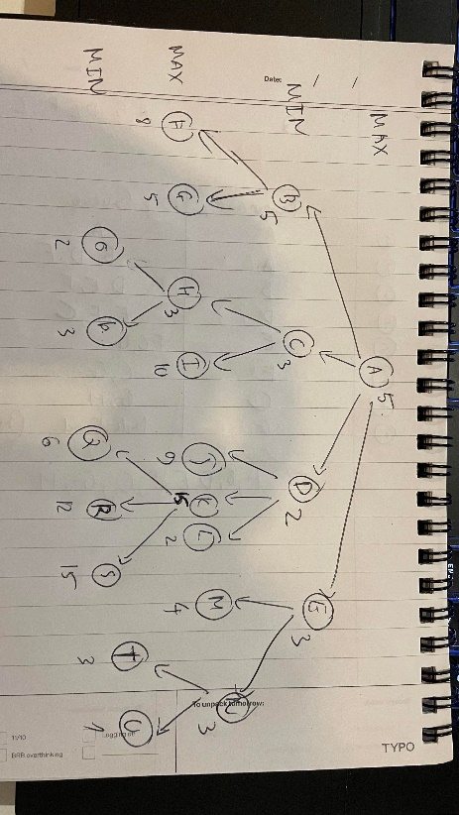

(6 marks)

1. Using **alpha-beta pruning**, the following nodes will be pruned from the search tree during the search process:

2

* 1. **P, K, Q, R, S, L, N, T, U** will be pruned.
  2. **I, L, N, T, U** will be pruned.
  3. **I, S, N, T, U** will be pruned.
  4. **P, S, U** will be pruned.
  5. **I, K, Q, R, S** will be pruned.
  6. **I, S, L, U** will be pruned.

(12 marks)